_T1071 (SafeCap+)

_D3.2 Tool support for modeling energy impact on performance

# Introduction

The on-going series of the SafeCap projects (sponsored by EPSRC and RSSB) focuses on improving capacity of railway nodes (junctions and stations) while ensuring their safety [1]. The projects have now developed a formal approach to safety verification and an integrated tooling environment that supports a domain-specific interface to help signalling engineers, formal safety verification and simulation used to calculate node capacity for various traffic scenarios. This work serves as a sound foundation for the development of the SafeCap train advisory system. This is now the area of the on-going work in the RSSB SafeCap+ project (2014-2016) that aims at developing novel modelling techniques and tools that support and explore integrated and efficient dynamic capacity of networks and nodes. As part of this approach, the SafeCap tooling environment will be expanded to include an energy plug-in providing an estimate of the energy usage implications of proposed service patterns.

This deliverable describes the SafeCap+ work to develop a qualitative model to capture train energy expenditure over a track layout. This will be used as an integral part of the SafeCap toolbox to provide richer advice output. The aim is to provide insight into the energy consumption implications of different alternatives for resolving traffic flow conflicts.

Section Error: Reference source not found details the development and an initial validation of the energy consumption calculation tool within the SafeCap+ project. Section 3 introduces on a real-world example developed to illustrate the capabilities of this tool. Wootton Bassett Junction, on the Great Western Main Line near Swindon, was chosen for this illustration. Measured data from the railway industry partners in the SafeCap+ project was used to ensure that this was a representative example of the day-to-day conflicts and resulting traffic management decisions that occur on the railway in Great Britain. Sections 3-4 reports our results of modelling this case study in an industry strength tool OpenTrack. The final evaluation of the SafeCap energy consumption calculation tool will be carried out at the final stage of the project by comparison of the OpenTrack models with the models to be developed in SafecCap.

# Energy Consumption Calculation in SafeCap

## SafeCap+ Sim3 development

The original SafeCap Platform provides an event-based simulator where simulation proceeds from one event to another. An event is typically a change in control law (i.e., switch from acceleration to coasting, aspect change) and within the extent of time defined by some adjacent events the system progresses according to some well-defined laws and the progression is determined solely by the boundary conditions of an extent. Thus, train progression would be defined by differential equation of movement and train dynamics. Such equations are non-linear but do have a closed form solution.

The situation changes considerably once an analytical model of train dynamics is replaced with model based on actual measurements of train performance where a constant function defines tractive effort available at a given speed. Such a model of train dynamics makes event-based simulation rather ill-suited as time gaps between events must be small at all times to preclude any significant error in the estimate of train speed or position. Hence, it was decided to develop a high-fidelity time-slicing simulator on the basis of the existing SafeCap infrastructure.

The material difference of the measurement-based model is that prediction of train speed and position cannot be given by a formula but rather requires a simulation run of its own. Hence operation of train acceleration and braking has to rely on rather different principle. To illustrate the approach taken consider the following speed plot:

V

V

S

B

C

H

Here the blue line defines the speed limit effective at the current moment. It combines speed restrictions imposed by fixed speed limits, signalling, scheduled stops and so on. A train must be driven so that its speed fits under this limiting curve. The plot shows how the train brakes in advance of a lower speed area. To perform a simulation one needs to be able to answer, wrt to some safety speed limit, which one of the following four modes applies:

* acceleration
* cruising
* coasting
* braking.

What is known, at any given point of time, is the following:

* train head position (H)
* train braking distance (B)
* train coasting stopping point (C)
* safety speed anywhere from point B

Determination of points C and B does not depend on the model of tractive effort and can be done analytically. First we consider the two phase model of acceleration/braking. A train is permitted to accelerate if the safety speed limit at point B is greater than zero. Symmetrically, braking must be engaged when speed limit at point B is zero. Notice that we do not consider speed limit between train head and point B. The safety envelope here is ensured by a combination of inertia (a train is unable to accelerate fast enough to violate safety) and the safety limit imposing extra restrictions at point B to ensure safety between points H and B. Since safety limit is constantly recomputed this gives effective control over maximum speed as well.

The two phase models, apart from excluding relevant phenomena of cruising and coasting, suffers from speed oscillation effect when a train travels at the maximum permissible speed. Indeed, once the train reaches the maximum speed, the safety precludes any further acceleration by indicating safe speed zero at point B. This triggers the braking phase which lasts only a short while since the safety limit at point B (now slightly farther forward) is above zero. And this way speed oscillates around the equilibrium of the maximum speed.

To counteract this a train can be made recognise that the maximum speed is reached and partial tractive effort must be used to sustain the speed. To detect the cruising stage, a train assesses the safety speed limit over the interval (B, B + delta). If the values on the interval fit exactly a certain pattern (zero at B, increases at certain rate towards B + delta) than the cruising phase is engaged. The phase will be re-evaluated and sustained for as long as cruising is appropriate.

The the phase model has the downside of driving to maximum train capability always engaging maximum acceleration (somewhat realistic) and maximum braking (not realistic). Real world trains typically operate with scheduling margins where more time is given to reach a timing than absolutely necessary. One way to approach this is to coast – let a train slow down and, possibly, stop due drag forces alone. Coasting must be engaged some time before braking is necessary but what time exactly isn't so easy to determine. As a phase, coasting competes with acceleration and cruising. That is, one needs to be able to make a choice between cruising and coasting or acceleration and coasting.

There is a number of factors that potentially determine usage of coasting: time table, energy saving, gradients, traffic optimisation. To try and account for all such factors we implemented so called performance function that advises a train when to engage coasting or partial braking. The performance function is recomputed at every simulation step so that it is able to react to change in system as such position of other trains, time table and so on. The range of the function lies in interval [0, 1] and determines the proportion of available traction and braking to be used. By default, it set to 1 meaning that a train is driven to its full capability but within a safety limit. At the opposite extreme, value 0 advises full braking. Value 0.5 prescribes neither traction nor braking and would make a train coast. Values above 0.5 and up to 1 correspond to partial tractive effort (typically, cruising at sub-maximal speed) and values above 0 and up to 0.5 define partial braking effort.

## Validation

Validation of SafeCap sim3 output against OpenTrack on a simple track layout.

# Real-world case study

## Introduction

One of the outcomes of the SafeCap+ project will be a comparison of the energy consumption information provided by the new SafeCap energy plug-in against real operational data. As well as testing the new features of the SafeCap toolset, this can also provide an insight into the energy consumption implications of different strategies to address capacity conflicts.

A case study was developed to meet the above objectives, based on Wootton Bassett Junction on the Great Western Main Line. A model of the junction was built in OpenTrack to develop a number of scenarios for this case study, and this model is illustrated in Figure 1. The boundaries of the model are Swindon in the east, and Chippenham and Hullavington in the west.

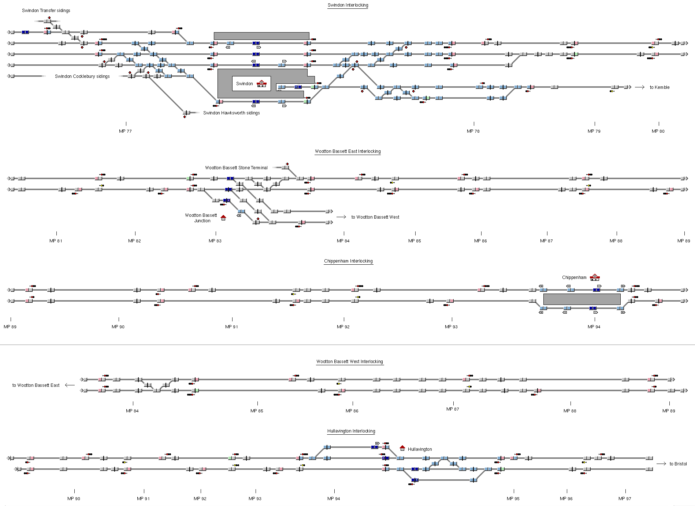

Figure 1. Wootton Bassett Junction modelled in OpenTrack

Three different train intercity passenger services were modelled and simulated:

1. An HST running from South Wales to London, via Bristol Parkway. The simulated part of the run starts at Hullavington (running at line speed), and finishes with the station stop at Swindon.
2. An HST from Bristol Temple Meads to London, which starts from the station stop at Chippenham and finishes with the station stop at Swindon.
3. An HST from London to South Wales, which starts at from a station stop at Swindon and leaves the model at Hullavington.

The OpenTrack simulation results were validated against data provided by (First) Great Western for each of these three trains, derived from the on-board Driver Advisory System fitted to their HSTs. The match between the simulated speed profiles and a number of different measured examples is illustrated by Figure 2 to Figure 4. The solid blue line is the OpenTrack output, and the three dotted/dashed red lines are measurements taken from three different trains in service.

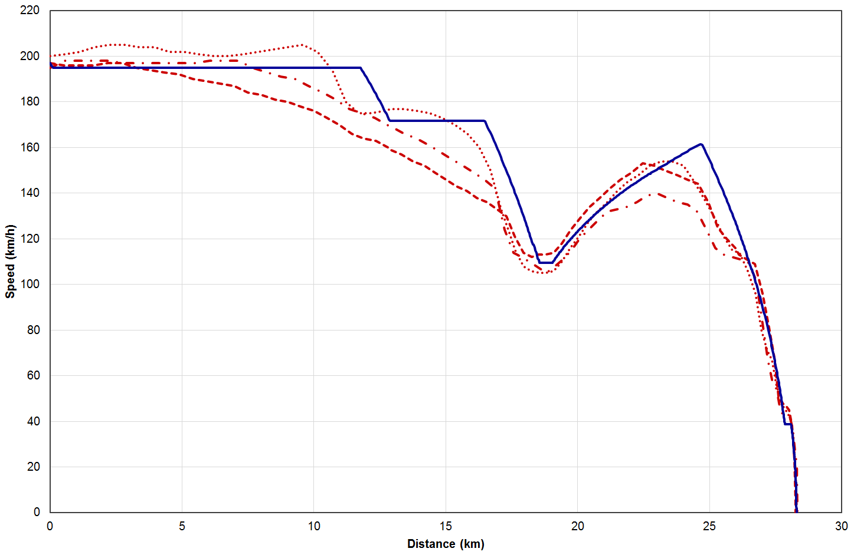

Figure 2. HST speed profiles (Train 1: Hullavington – Swindon)

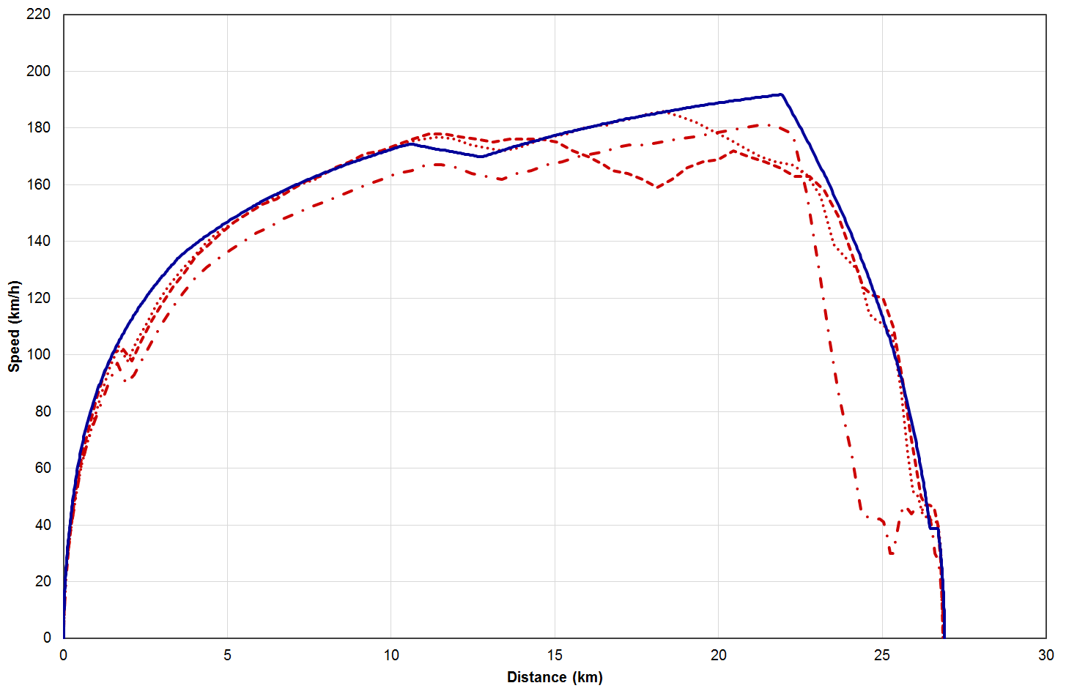

Figure 3. HST speed profiles (Train 2: Chippenham – Swindon)

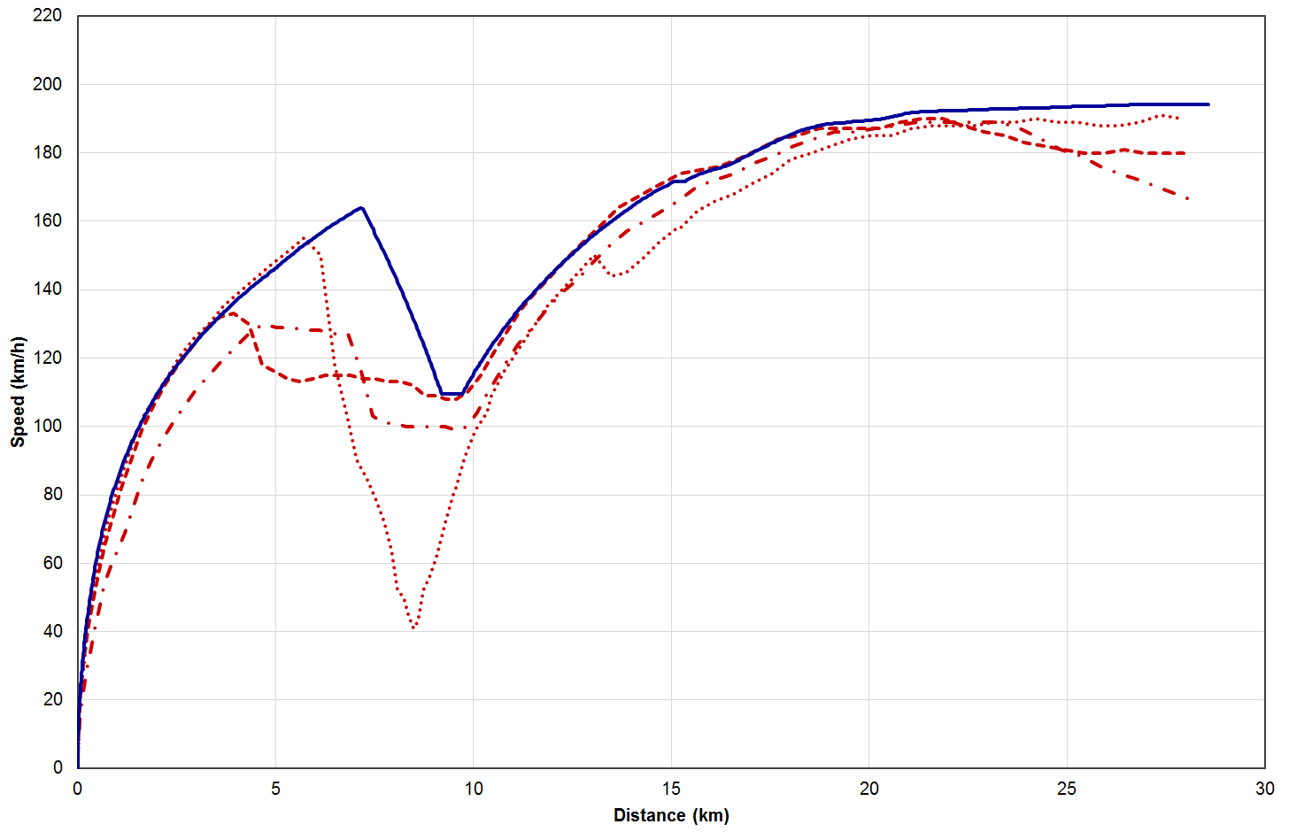

Figure 4. HST speed profiles (Train 3: Swindon – Hullavington)

After validation, the OpenTrack model was used to develop seven different scenarios for the case study, representing different traffic management decisions to resolve a conflict at Wootton Bassett Junction. These scenarios are described in section 3.2.

## Case study scenarios

The seven case study scenarios are based on the interaction of the three trains described in section 3.1 at Wootton Bassett Junction:

* Train 1 is supposed to enter the area at Hullavington at the start of the time period modelled, but is running twelve and a half minutes late.
* Train 2 departs Chippenham ten minutes after the train 1 was timetabled to pass Hullavington.
* Train 3 departs Swindon five minutes after the second train departs Chippenham.

The delay to train 1 creates a conflict with train 2, as it means that both trains converge on Wootton Bassett Junction at a similar time. If train 2 is delayed by a sufficient amount as a result, it can create a further conflict with train 3, as their paths cross at the junction.

Seven different options were defined for resolving this conflict, as follows:

1. Keep the order of trains passing the junction as originally planned; trains use all-out running to arrive at their destinations as quickly as possible.
2. Swap the order of train 1 and train 2, giving train 2 priority to pass the junction first; use all-out running.
3. Keep the original train order; all trains are fitted with a standalone Driver Advisory System (S-DAS) to coast and save energy when running on time, in this case train 2 and train 3.
4. Swap the order of train 1 and train 2; S-DAS is fitted and trains 2 and 3 use coasting.
5. Keep the original train order; all trains are fitted with a Connected Driver Advisory System (C-DAS) that knows about upcoming junction conflicts and instructs trains to coast early (rather than brake immediately before) adverse signals, C-DAS strategy is to minimise braking for trains 2 and 3 to keep them moving.
6. Keep the original train order; C-DAS is fitted, and the strategy is to allow some braking if it reduces delay compared to option v).
7. Swap the order of train 1 and train 2; C-DAS is fitted and all trains use coasting, before adverse signals for trains 1 and 3 and after clearing the junction for train 2.

The OpenTrack tools calculated the delay to each train when leaving the area of the case study, and the energy consumption, and these are detailed in section 3.3.

## Results

The results for each of the seven options are summarised in Table 1. The arrival/passing time at each train’s destination relative to the timetable is given, also stated as a delay figure to the nearest quarter minute. The energy consumption is shown for each train, and overall, relative to the base case of option i).

Table 1. Summary of results

|  |  |  |  |  |  |
| --- | --- | --- | --- | --- | --- |
| **Option** | **Train** | **Arrival time (seconds)** | **Delay  (minutes)** | **Energy consumption** | |
| i) | 1 | +665 | 11 late | 100% | 100% |
| 2 | +170 | 2¾ late | 100% |
| 3 | +38 | ¾ late | 100% |
| ii) | 1 | +728 | 12¼ late | 110% | 95% |
| 2 | -86 | On time | 89% |
| 3 | -71 | On time | 94% |
| iii) | 1 | +665 | 11 late | 100% | 93% |
| 2 | +170 | 2¾ late | 98% |
| 3 | +23 | ½ late | 86% |
| iv) | 1 | +803 | 13½ late | 116% | 80% |
| 2 | -11 | On time | 61% |
| 3 | -14 | On time | 79% |
| v) | 1 | +665 | 11 late | 100% | 79% |
| 2 | +173 | 3 late | 68% |
| 3 | +103 | 1¾ late | 78% |
| vi) | 1 | +665 | 11 late | 100% | 87% |
| 2 | +162 | 2¾ late | 78% |
| 3 | +13 | ¼ late | 87% |
| vii) | 1 | +724 | 12 late | 59% | 73% |
| 2 | -71 | On time | 75% |
| 3 | -14 | On time | 79% |

Figure 5 to Figure 11 illustrate the distance-time and speed-time profiles of the three trains for each of the seven options. These may be compared against the speed-distance profiles in Figure 2 to Figure 4.

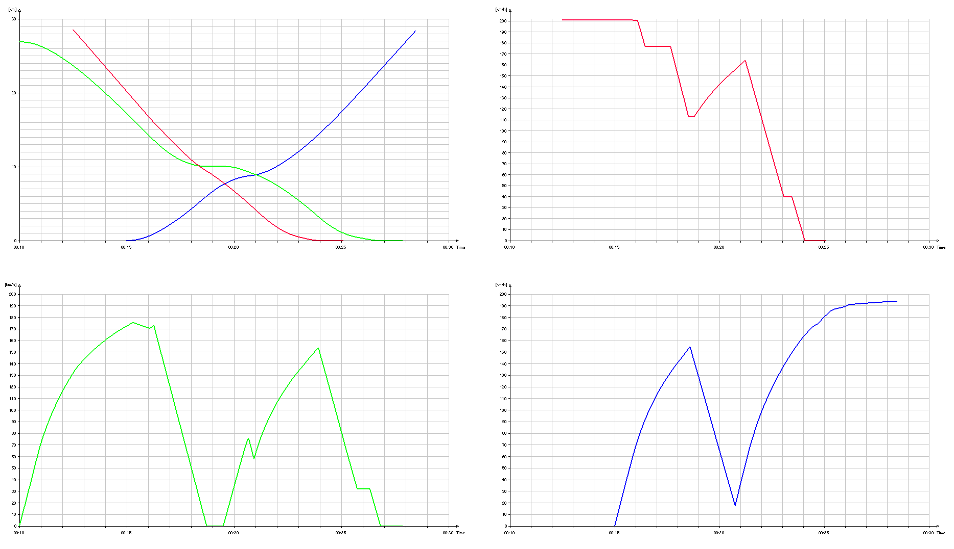

Figure 5. Option i) profiles

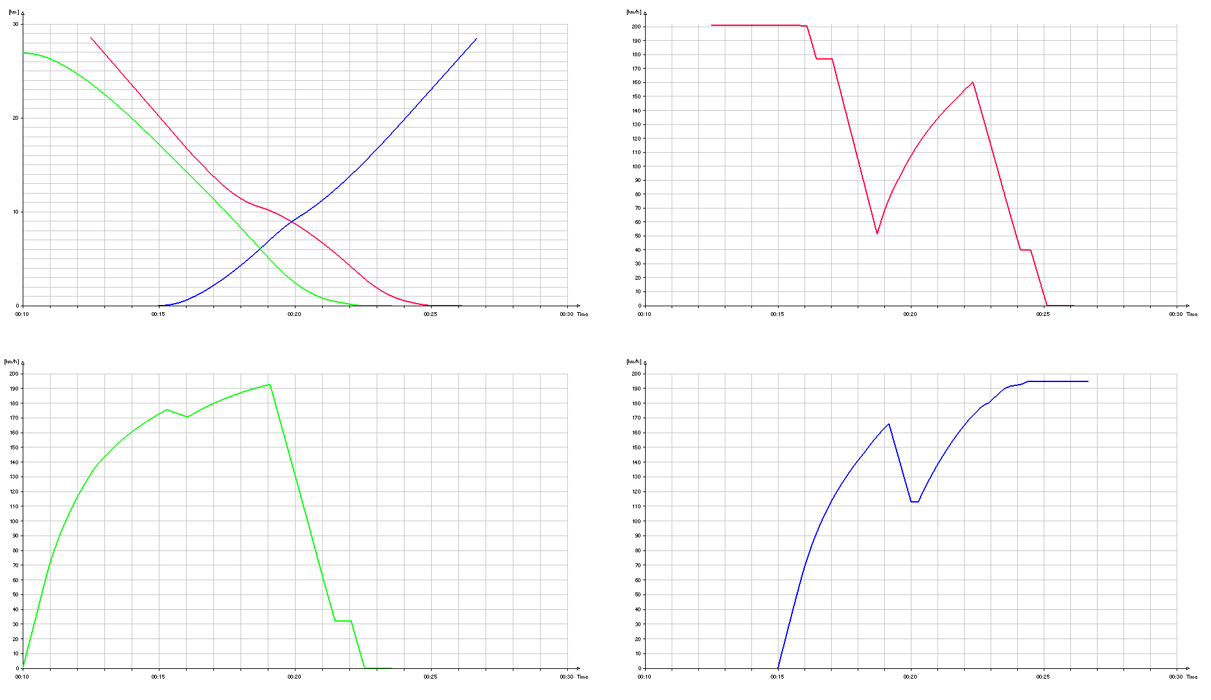

Figure 6. Option ii) profiles

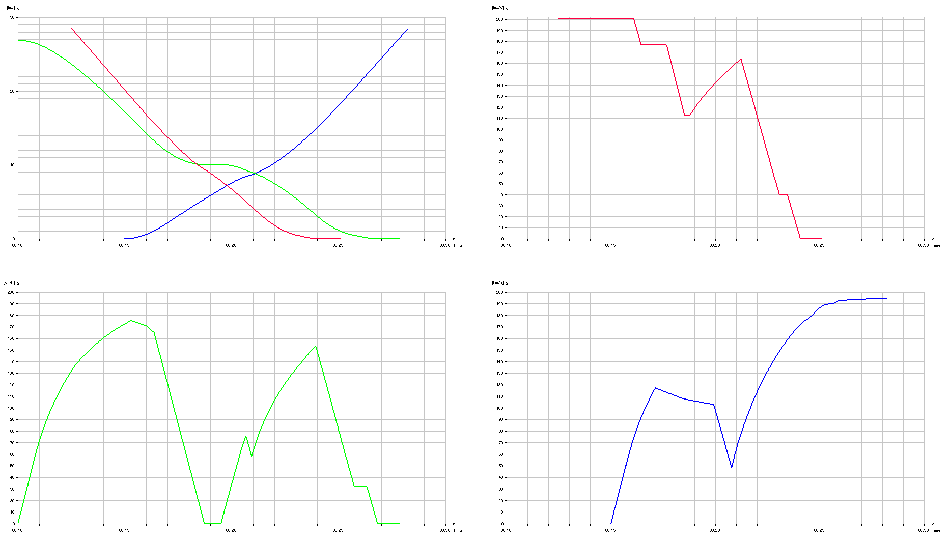

Figure 7. Option iii) profiles

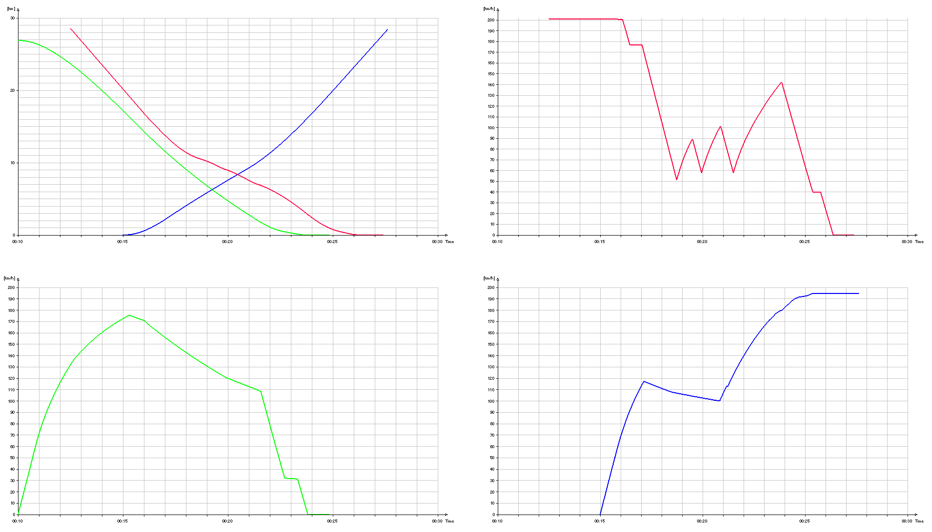

Figure 8. Option iv) profiles

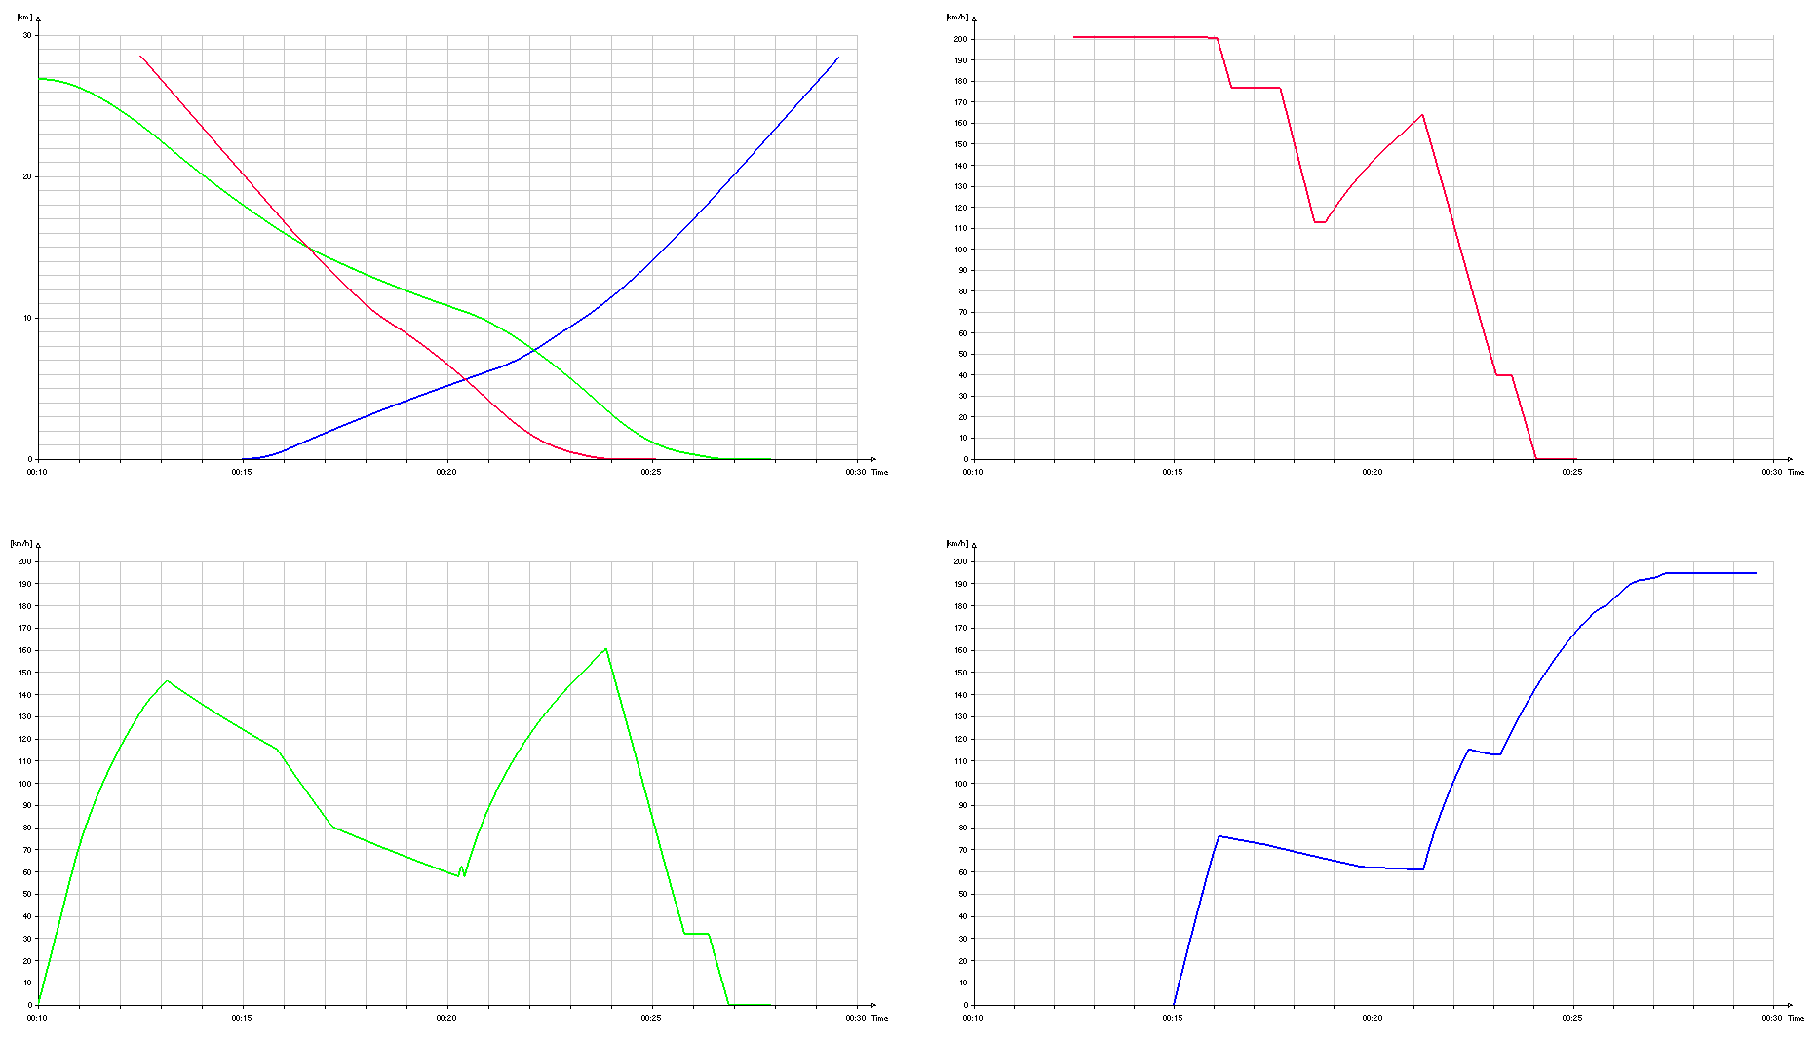

Figure 9. Option v) profiles

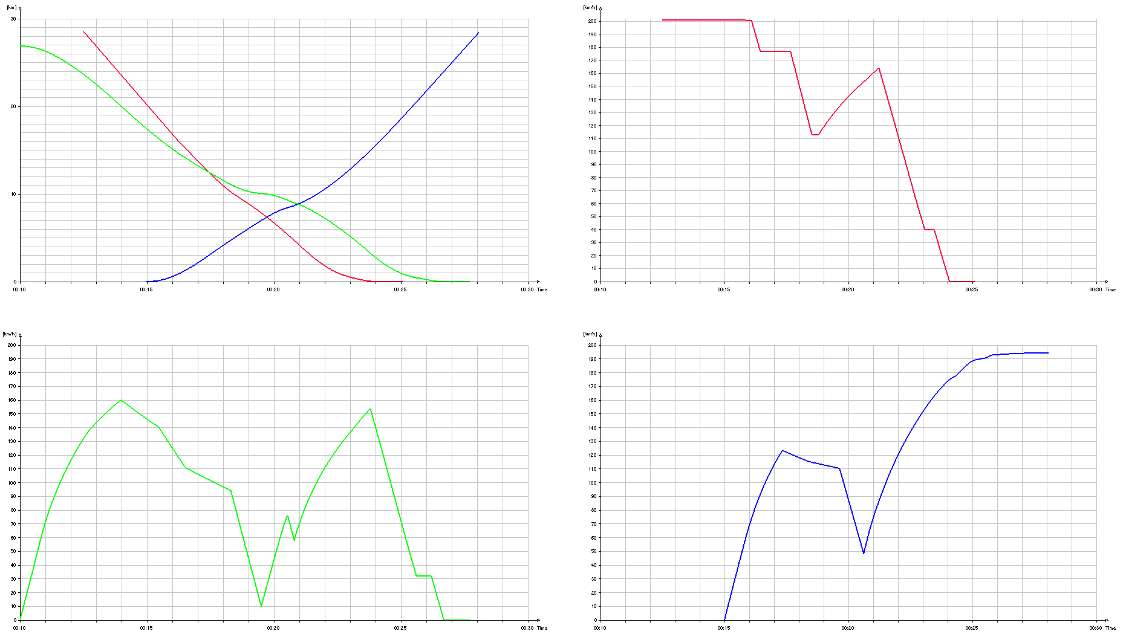

Figure 10. Option vi) profiles

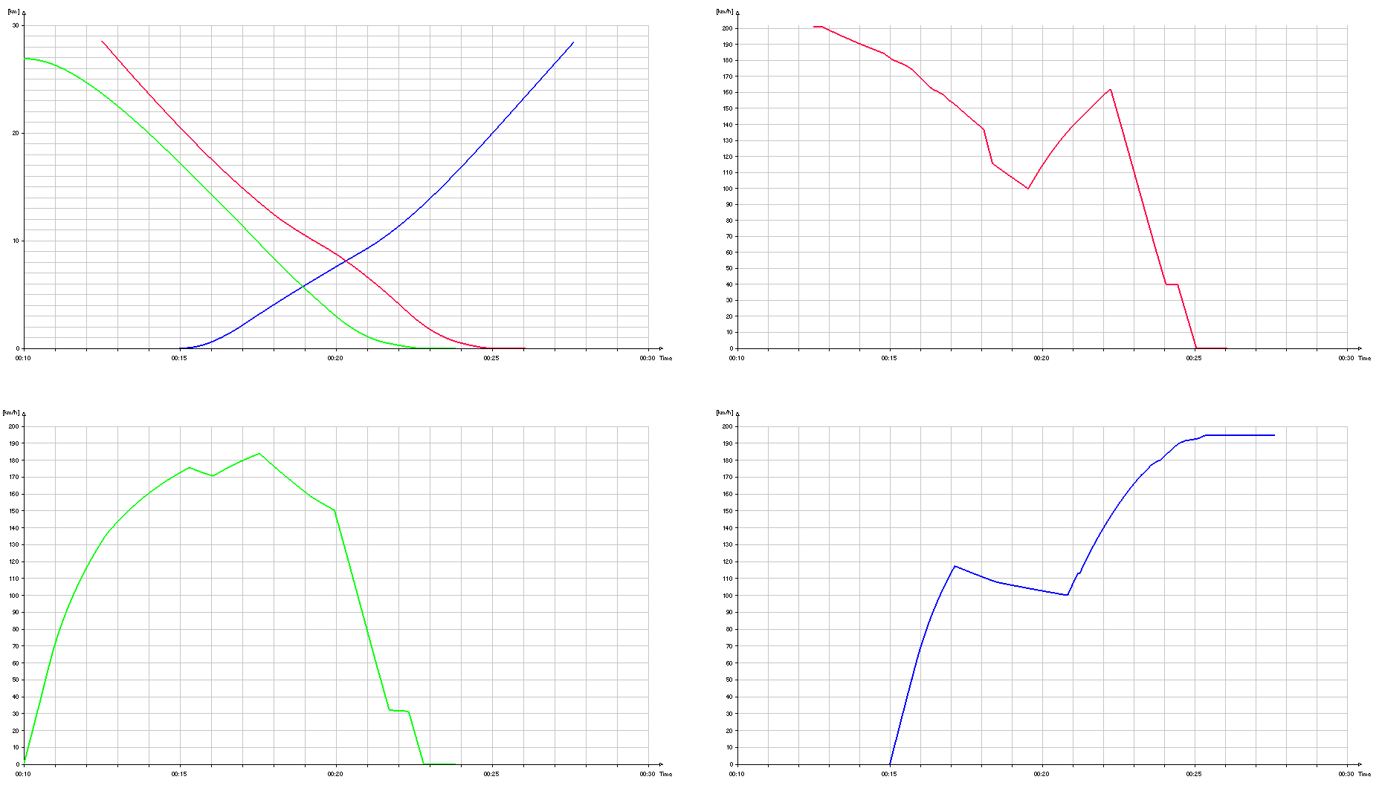

Figure 11. Option vii) profiles

A brief discussion of these results is contained in section 3.4, and the overall conclusions are in section 4.

## Discussion

Keeping the train order of trains passing Wootton Bassett Junction as planned in option i) results in train 2 stopping at signal SN45, and the time taken to restart, accelerate and clear the junction means that train 3 is almost brought to a stand at signal SN62. This causes delays to both trains compared to their timetable. Train 1 does however recover around one and a half minutes of its twelve and a half minute delay.

Swapping the order of train 1 and train 2 in option ii) means that train 2 and train 3 are no longer restricted by signals and are no longer delayed, but train 1 has to brake for signal SN143 as the junction is blocked by train 2, and therefore can only recover around twenty seconds of its initial delay. However, swapping the order of trains is not always an option, as it may have implications elsewhere in the system later on. For example, train 2 may have additional stations stops after Swindon that train 1 was not timetabled to stop at. The energy consumption of trains 2 and 3 is reduced, as the extra energy consumed from running at a higher speed is more than offset by the saving from not having to reaccelerate from a slow speed at the junction. This requirement to reaccelerate does increase the energy consumption of train 1, but less energy is consumed in total for this option.

In option iii), train 2 only has the opportunity for a brief period of coasting before having to brake for signal SN45, which provides a small reduction in energy consumption compared to option i), but no change in delay as the speed profile after restarting is identical. Train 3 is able to coast for a longer period of time in anticipation of its planned passing time at Wootton Bassett Junction before having to brake, which provides a greater reduction in energy use. As train 3 arrives at the junction slightly later than for option i), it is travelling at a higher speed when signal SN62 clears, and so its overall delay is actually reduced by comparison, as reaccelerating from a higher initial speed more than offsets the later passing time at the junction. Its energy use is also reduced. Note that in reality, coasting is part of professional driving practise and so comparing S-DAS against all-out running is likely to overstate its benefits, as the best drivers are likely to be able to approach S-DAS results by themselves. The principal benefit of implementing S-DAS is to reduce the variation between drivers, and allow speed profiles closer to the optimum to be used more regularly and consistently.

The use of coasting for trains 2 and 3 in option iv) significantly reduces energy consumption compared to option ii), and they arrive/pass their destinations at close to their planned time rather than over a minute early. However, this means that train 2 clears the junction later, and is travelling at a lower speed on the approach to Swindon, and this increases the train 1’s delay by around a minute. Train 1’s energy consumption is also increased compared to option ii), due to brake applications on the approach to the junction, and in the following signal sections as it catches up with the slower-running train 2. In this case, the use of S-DAS actually worsens the overall delays, as coasting advice for a train running on time does not take into account the effects on following (late-running) trains.

In option v), the strategy is for C-DAS to advise train 2 and 3 to coast on the approach to the junction rather than brake, in order to minimise the energy consumption. This provides a significant reduction in energy consumption compared to options i) and iii), but the delay to train 3 is increased, by contrast with the reduction observed in option iii). This is because train 2 takes longer to clear the junction than previously. The signal spacing between Wootton Bassett Junction and Swindon is for a line speed of 125 mph, but all trains from Hullavington (like train 1) are restricted to 70 mph at Wootton Basset Junction. Train 2 is therefore travelling at a lower speed to avoid braking for signals UM82 and UM81 after the junction, which is why it clears the junction later. This illustrates that for lineside signalling, the capacity constraint at a converging junction may not be the junction itself, but the following signal sections if the speed limits of the converging lines are different to each other.

An alternative strategy for C-DAS is to aim for minimum delay, rather than minimum energy. In option vi), train 2 and train 3 approach the junction at a higher speed, and are required to brake (train 2 is also required to brake after it has cleared the junction). This strategy means train 2 clears the junction earlier, and reduces the delay compared to option v), albeit at the cost of a higher energy consumption. The delay and energy consumption are both lower when compared to option i) and option iii) however. Different C-DAS strategies will depend on the characteristics of the railway system in question.

The C-DAS in option vii) ensures that train 2 has cleared the junction before starting to coast, which means an early arrival at Swindon and higher train individual energy consumption than option iv), but this prevents train 1 from being delayed further. Train 1 has a significantly reduced energy consumption from coasting, and a few extra seconds of delay reduction compared to all-out running in option ii), similar to the benefits obtained by train 3 in option iii). Train 3 is able to obtain the maximum benefits from coasting as the junction is clear, as was the case for option iv).

# Conclusions

Energy consumption calculations have been built into the SafeCap toolset and an initial validation has been carried out against OpenTrack data. OpenTrack was also used to develop a demonstration exercise to test the new features of SafeCap further, illustrating how SafeCap can provide both the delay and energy consumption implications of different traffic management decisions, using real world data for Wootton Bassett Junction from the project’s railway industry partners.

Seven different options were defined for dealing with a conflict caused by a late-running train, including the use of Standalone and Connected Driver Advisory Systems. These options demonstrate the potential trade-off required between minimising the delay of a train that is already late, and preventing the delay from spreading to other trains. These options were modelled in OpenTrack to allow us to conduct full evaluation of the new SafeCap tools at the final stage of the project. T.

The seven decisions essentially consist of the order of trains at junctions, and the time/location for trains to start/stop coasting. In this exercise, they were specifically designed to illustrate some of the potential traffic management issues in a representative environment. Future development work is intended to allow the SafeCap toolset to generate, evaluate and rank its own sets of decisions automatically, so that it could present a set of options for minimising individual train delays and energy consumption in response to any potential set of initial delays to a number of trains running over a given infrastructure.

# References

1. Iliasov, A., Lopatkin, I., Romanovsky, A., *SafeCap: advanced computer science techniques for railways of tomorrow*, in *EURAILmag*. 2013. p. 76-78.